**A**

**Project Report**

**On**

**“Image Classification”**

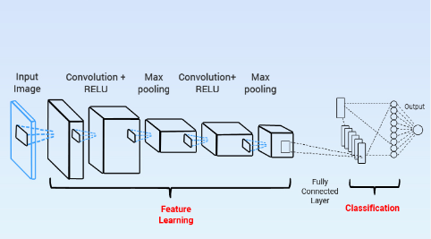

**BY**

Muhammad Faizan Khan (BScsF20-10)

**Submitted To**

Sir Zahoor Rehman

**Institute**

**“Qarshi University”**

